**DEMOGRAPHICS OF CASUALTY:**

*Demographics – statistics describing population/individual and their characteristics*

*Eg. Age, Sex, Income, Postcode*

*Demographics Data: socioeconomic information expressed statistically.*

*Demographic Pattern: pattern revealed by population*

*Demographics pattern by sex*

*Available demographic data of casualties – age, age band and sex*

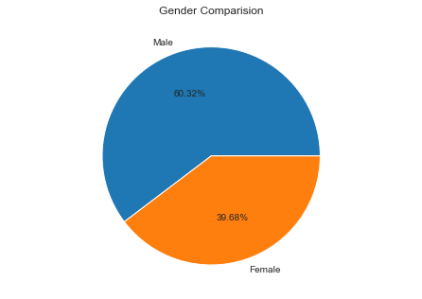

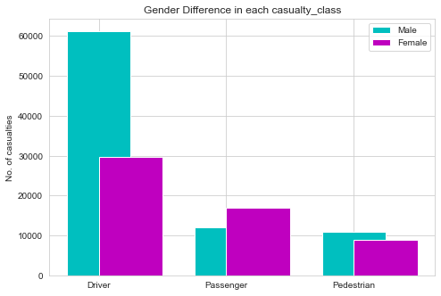

*In total casualties ,  
In 2019, total casualties -1,53,158 59.47% are drivers.*

*->Male = 84314 (60.32%) In total drivers 67.3% are male casualties*

*->Female = 55465 (39.68%)*

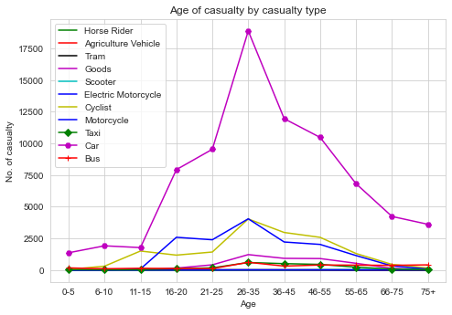

*Demographics pattern by age: 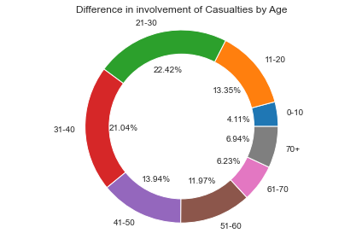*

*Max of casualties are between 21 – 40 ,*

*In those 43.46%, most of them are involved in car accidents and max are from 25-35*

**Pedestrians KSI Casualties**

*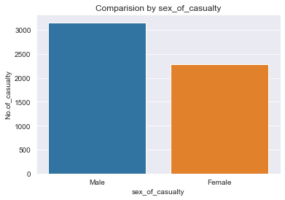 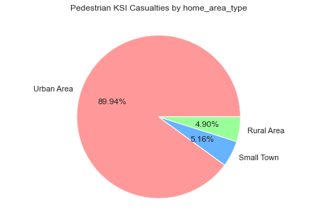 Total Casualties = 1,53,158 Max of Pedestrian KSI Casualties involved are Total Pedestrians =19774*

*From urban areas (4897) Pedestrian KSI Casualties = 5445* Male=3156 (57.96%) Female = 2289 (42.03%)

